Run 1:
Parameters:
BATCH_SIZE = 128
GAMMA = 0.999
EPS_START = 0.9
EPS_END = 0.05
EPS_DECAY = 100
TARGET_UPDATE = 10
Loss: SmoothL1Loss
Optimizer: Adam
policy_net.parameters.grad.data.clamp_(-1, 1)
Observation: (~25s) Result improved before t=200, get worsen after that
Hypothesis:
1. The policy_net is not good enough to be sampled even at t=200, random movement is still better
(tested, the actions selected stablise at about ep=25)
Next:
1. Plot action_select from sample or from policy_net
2. Update target net more often
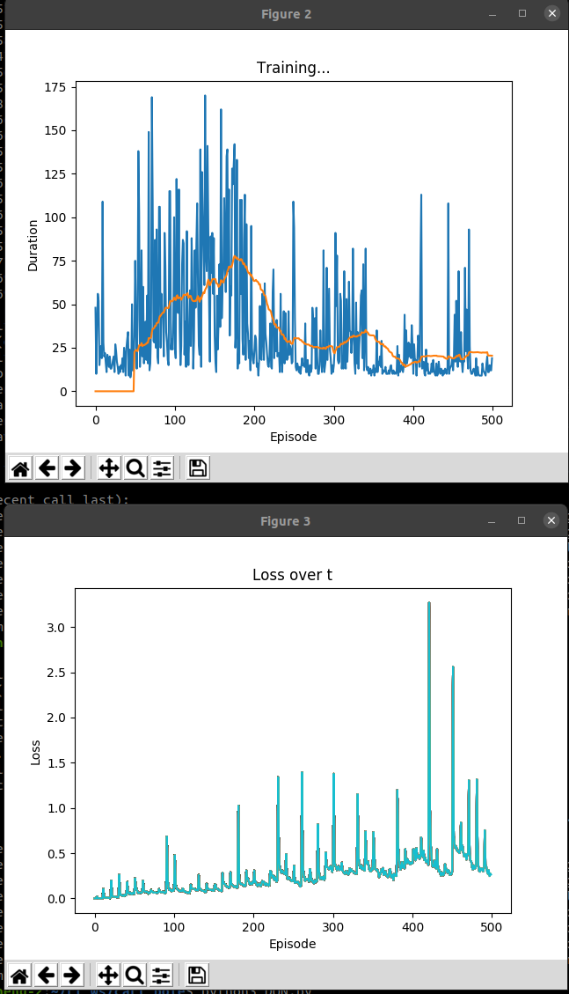
Run 2:
Parameters:
BATCH_SIZE = 128
GAMMA = 0.999
EPS_START = 0.9
EPS_END = 0.05
EPS_DECAY = 100
TARGET_UPDATE = 5 #from 10
Loss: SmoothL1Loss
Optimizer: Adam
policy_net.parameters.grad.data.clamp_(-1, 1)
Observation: (~50s)Result improved when target_net update double the frequency, get worsen after 300, the cart kept choosing the same failed action
Hypothesis:
1.
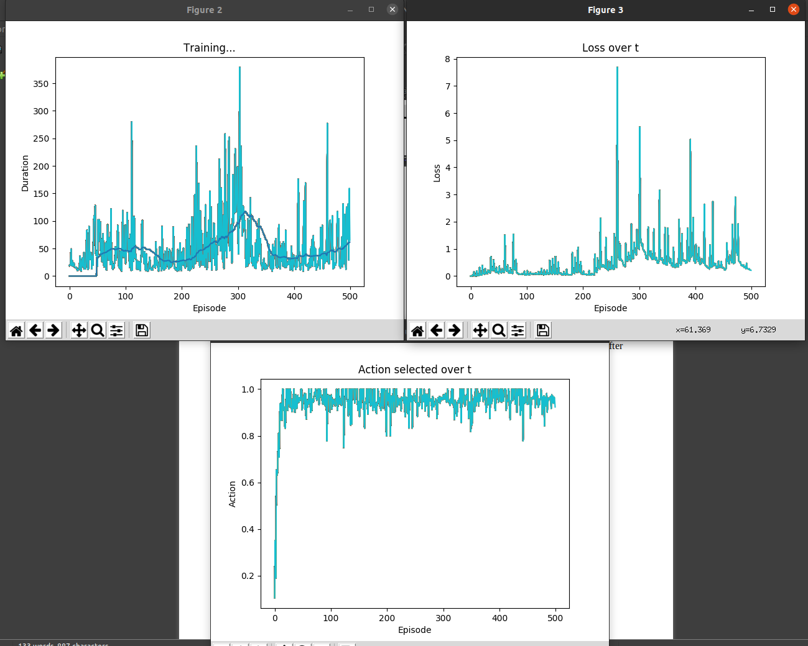
Run 3:
Parameters:
BATCH_SIZE = 128
GAMMA = 0.999
EPS_START = 0.9
EPS_END = 0.025
EPS_DECAY = 100 #200
TARGET_UPDATE = 5
Loss: nn.HuberLoss()
Optimizer: optim.Adam(policy_net.parameters())
policy_net.parameters.grad.data.clamp_(-1, 1)
Observation: (~40s)
Hypothesis:
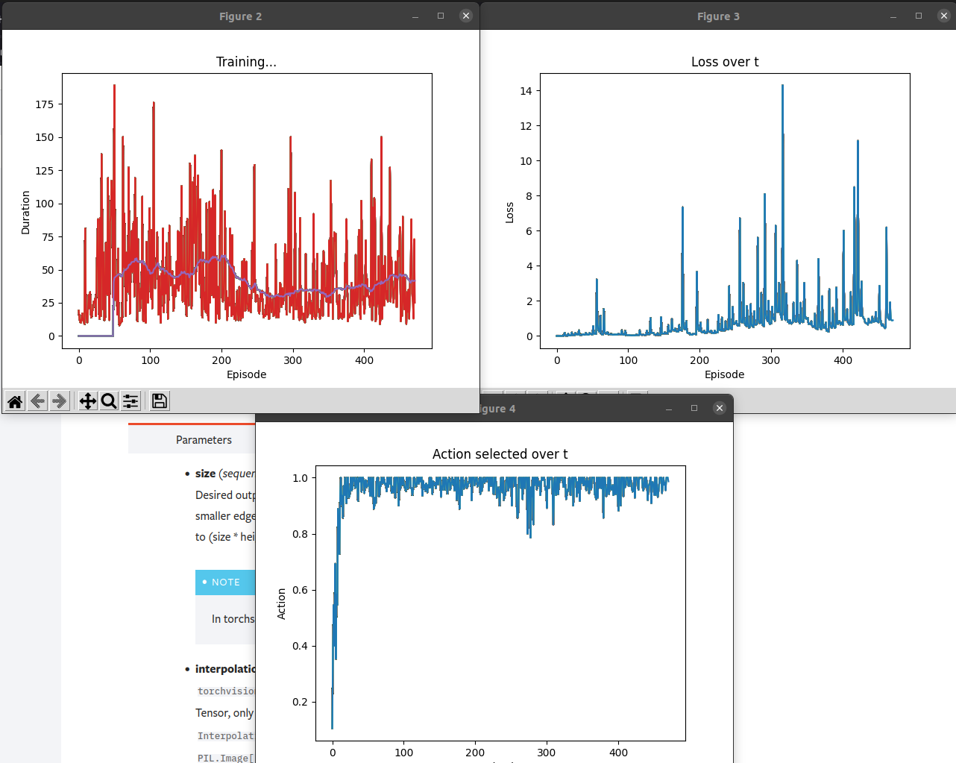
Run 4:
Parameters:
BATCH_SIZE = 128
GAMMA = 0.999
EPS_START = 0.9
EPS_END = 0.04
EPS_DECAY = 100
TARGET_UPDATE = 10

Loss: nn.HuberLoss()
Optimizer: optim.Adam(policy_net.parameters())
policy_net.parameters.grad.data.clamp_(-1, 1)
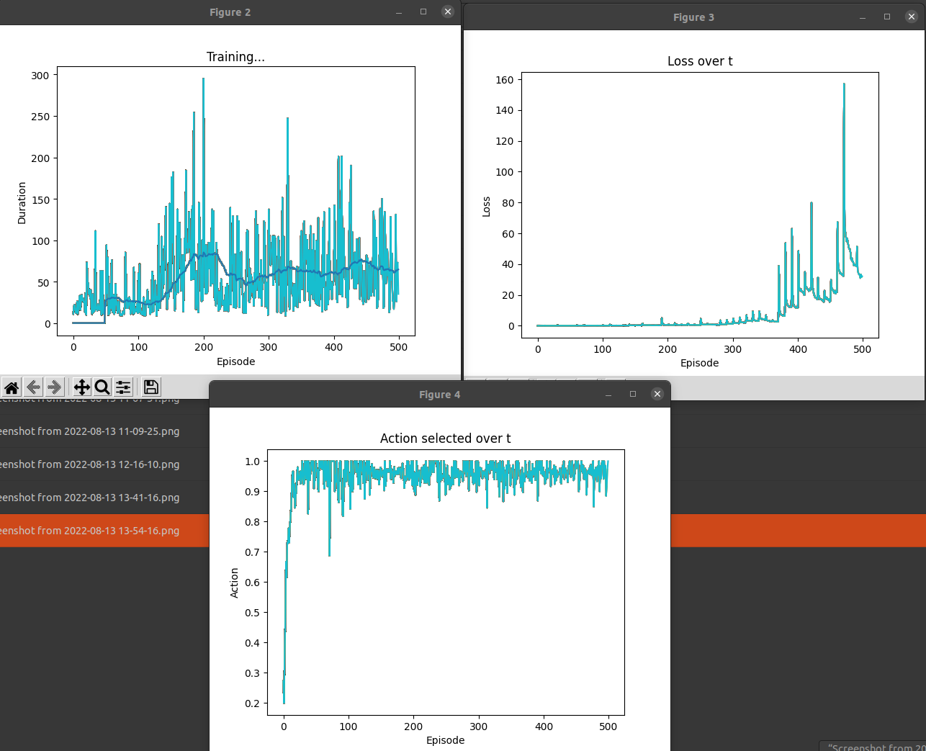
Observation: (~65s)
Run 5:
Parameters:
BATCH_SIZE = 128
GAMMA = 0.99
EPS_START = 0.9
EPS_END = 0.04
EPS_DECAY = 100
TARGET_UPDATE = 10

Loss: nn.SmoothL1Loss()
Optimizer: optim.Adam(policy_net.parameters())
policy_net.parameters.grad.data.clamp_(-1, 1)
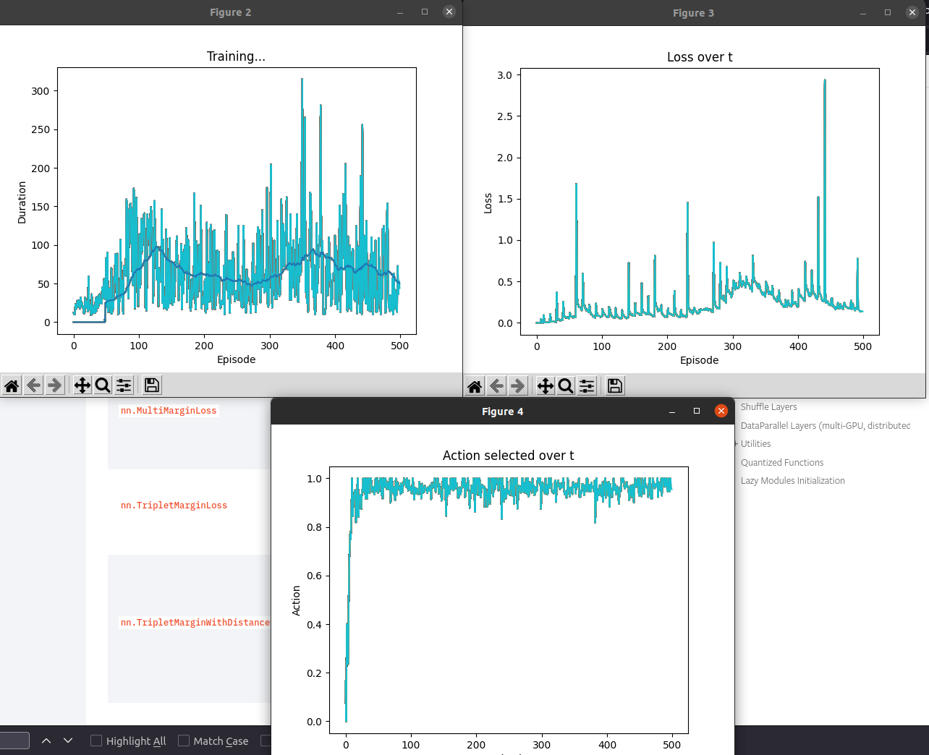
Observation: (~51s)
Run 6:
Parameters:
BATCH_SIZE = 128
GAMMA = 0.95
EPS_START = 0.9
EPS_END = 0.1
EPS_DECAY = 100
TARGET_UPDATE = 7

Loss: nn.SmoothL1Loss()
Optimizer: optim.Adam(policy_net.parameters())
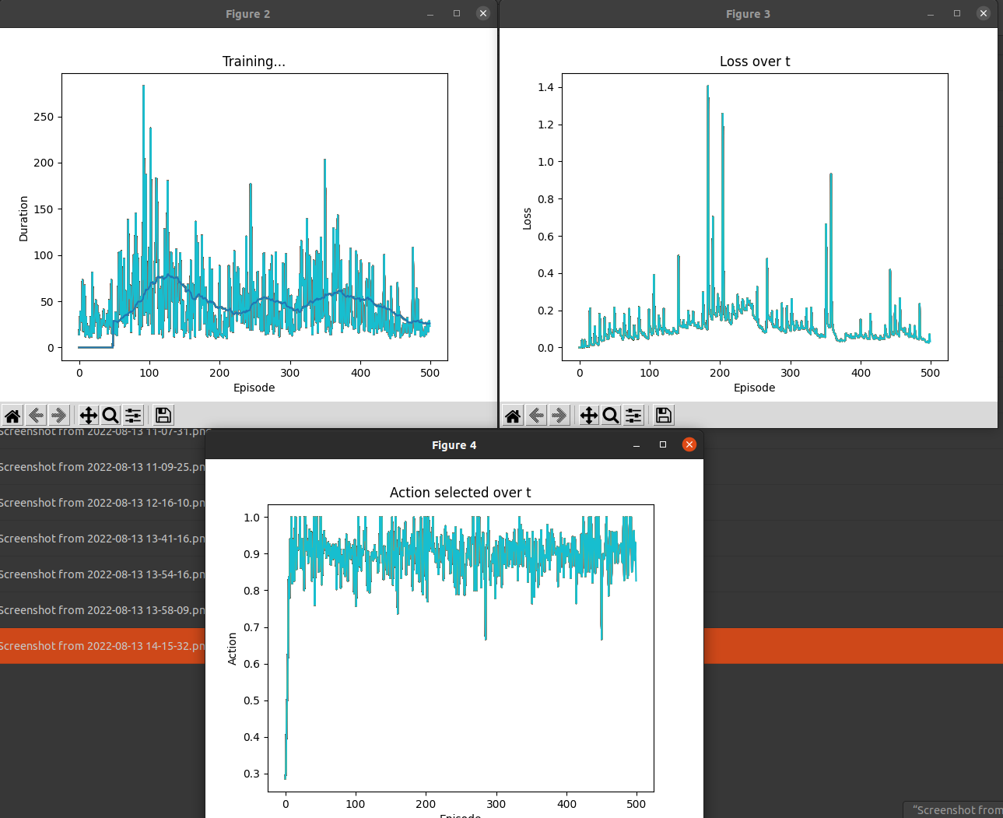
policy_net.parameters.grad.data.clamp_(-1, 1)
Observation: 40
Run 7:
Parameters:
BABATCH_SIZE = 128
GAMMA = 0.995
EPS_START = 0.9
EPS_END = 0.01
EPS_DECAY = 100
TARGET_UPDATE = 7

Loss: nn.SmoothL1Loss()
Optimizer: optim.Adam(policy_net.parameters())
policy_net.parameters.grad.data.clamp_(-1, 1)
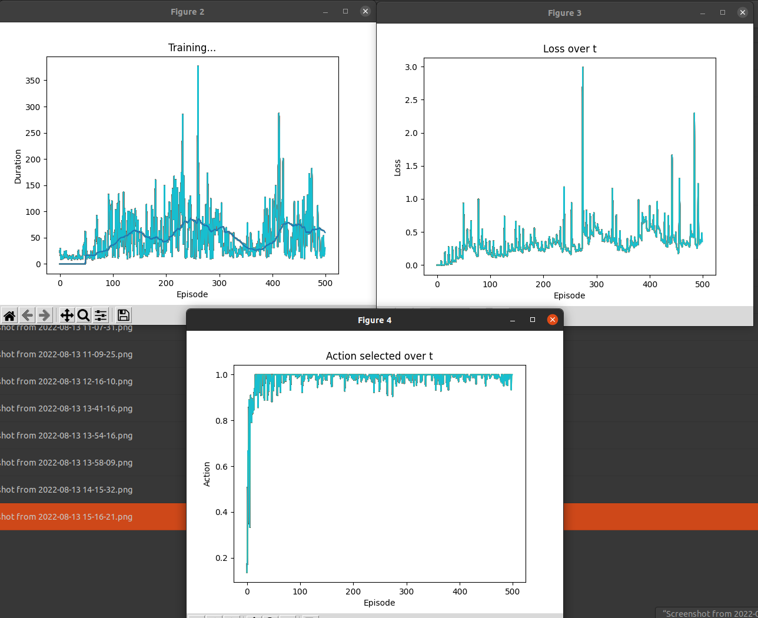
Result: 57t
Run 8:
Parameters:
BATCH_SIZE = 128
GAMMA = 0.999
EPS_START = 0.9
EPS_END = 0.04
EPS_DECAY = 100
TARGET_UPDATE = 10

criterion = nn.HuberLoss()
optimizer = optim.RMSprop(policy_net.parameters())

policy_net.parameters.grad.data.clamp_(-1, 1)
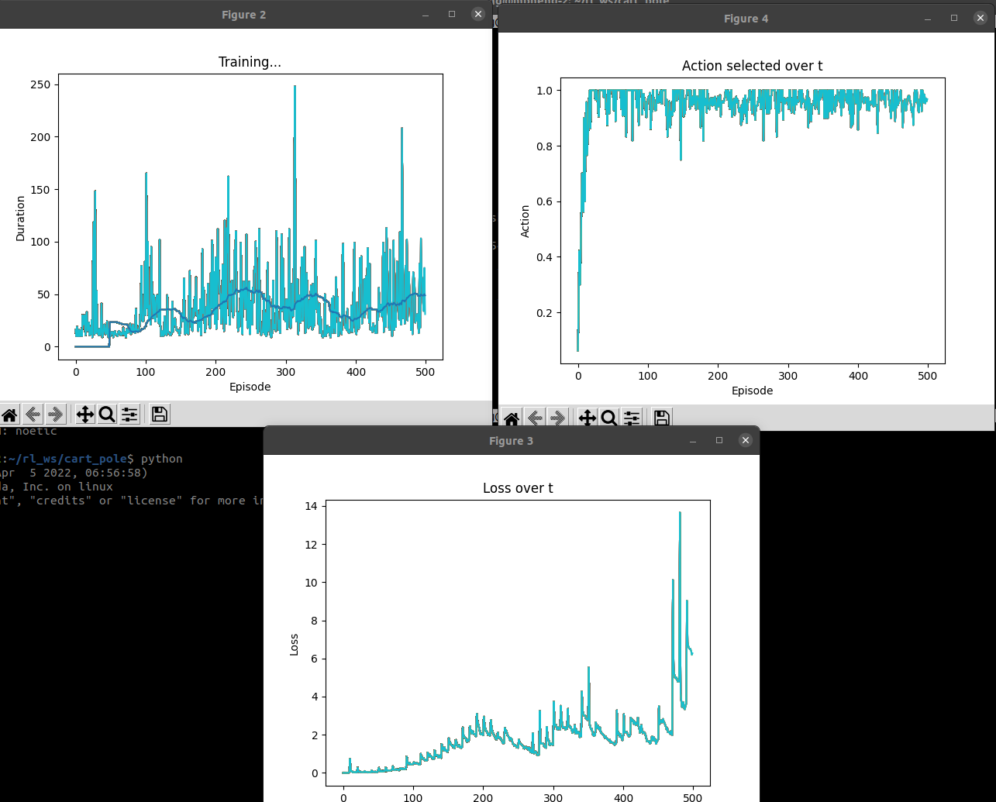
Result: 46
Run 9:
Parameters:
BATCH_SIZE = 128
GAMMA = 0.999
EPS_START = 0.9
EPS_END = 0.035
EPS_DECAY = 100
TARGET_UPDATE = 15

criterion = nn.HuberLoss()
optimizer = optim.Adam(policy_net.parameters())

policy_net.parameters.grad.data.clamp_(-1, 1)
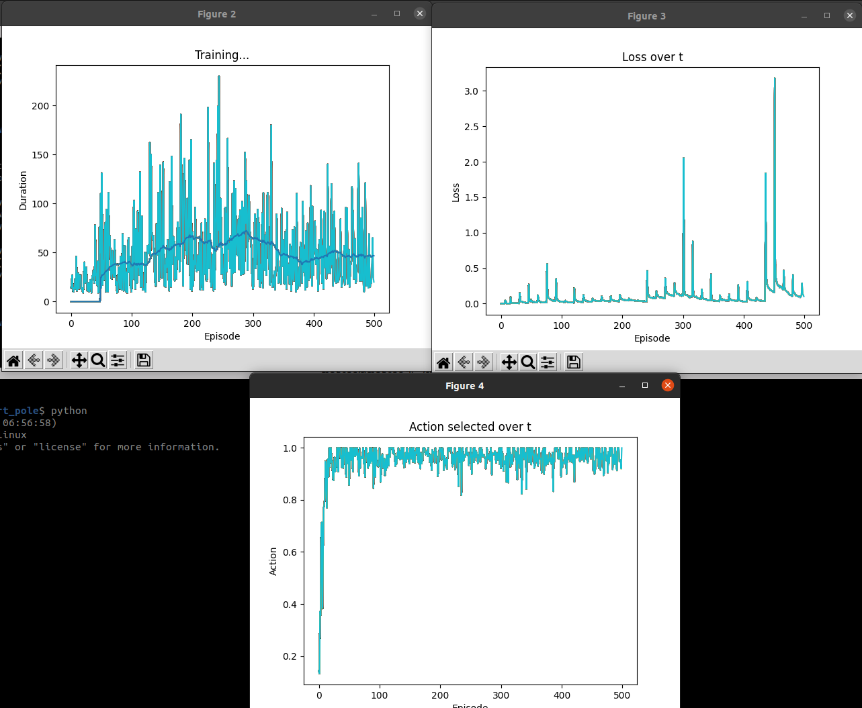
Result: 46

